Window basic investigation
1. Current logged-in user kaun hai?
Command
whoami
Answer
Current logged-in username show karega.
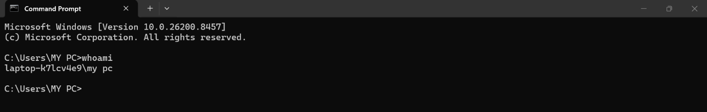
SOC POV
Agar attacker compromised system pe login kare to analyst check karta hai kaun user active hai.(jab bahut badhi organisation mai check karna ho konsa system , kon user hai) (iskme basically system ka name + jo apne apne pc ko name de Rakha hai)

2. System ka hostname kya hai?
hostname
Answer
Computer ka name show karega.
SOC POV
SIEM logs me host identify karne ke liye important.

3. System ki full information dekho
systeminfo
Answer
OS version, RAM, patch level.
- System boot time kal ka dikhara cause yeh follow karta hai fast startup when u shutdown your system I will save your state so that jab app use agli baar kholo to vo vahi fast kaam ho and aggr apko firse boot fresh karna hai then you have to restart it not shutdown .
- System locale – default language
- Input locale- used by keybord (english)
- Hotfix- targeted released update to fix any bug
- Virtual based security- hardware feature that create isolated secure memory known as virtual secure mode so that If attacker gain full kernal acess it cannot os
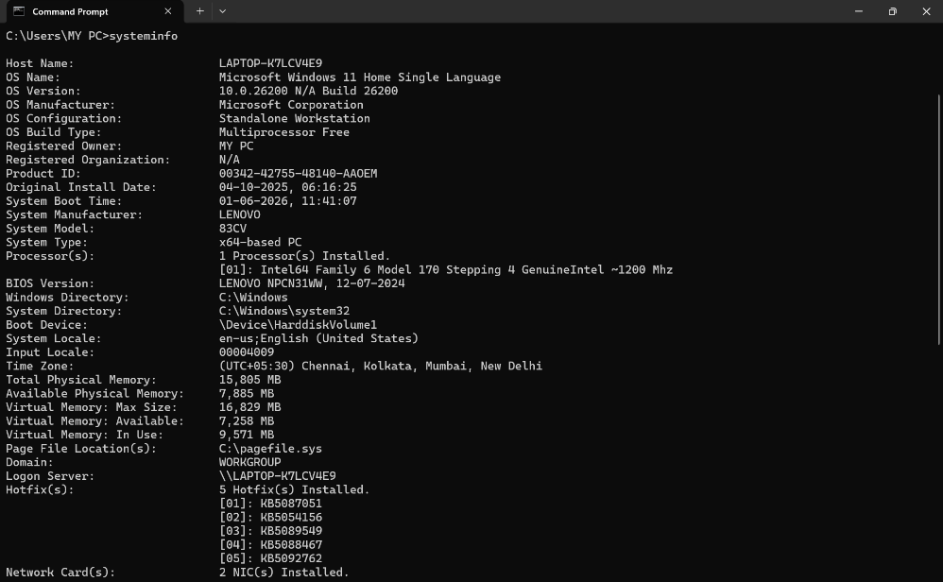
SOC POV
Outdated systems exploit hone ke chances zyada.

4. System uptime(boot time) check karo
systeminfo | find "Boot"
SOC POV
Recent reboot kab hua pata chalta hai.

5. All running processes dekho
tasklist
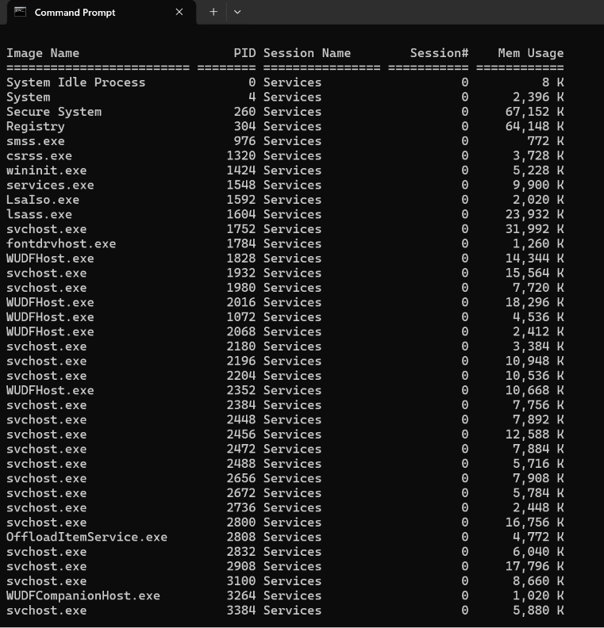
SOC POV
Malicious processes detect karne ke liye
- Pid – process ki unique id hai
- Session 0 – hota hai background activity k liye
- Mem- hota ram usage
- And 300-500 mb is normal usage of memory
- N- issas.exe S-issas.exe(using a “1”)

6. Specific process search karo
tasklist | findstr chrome
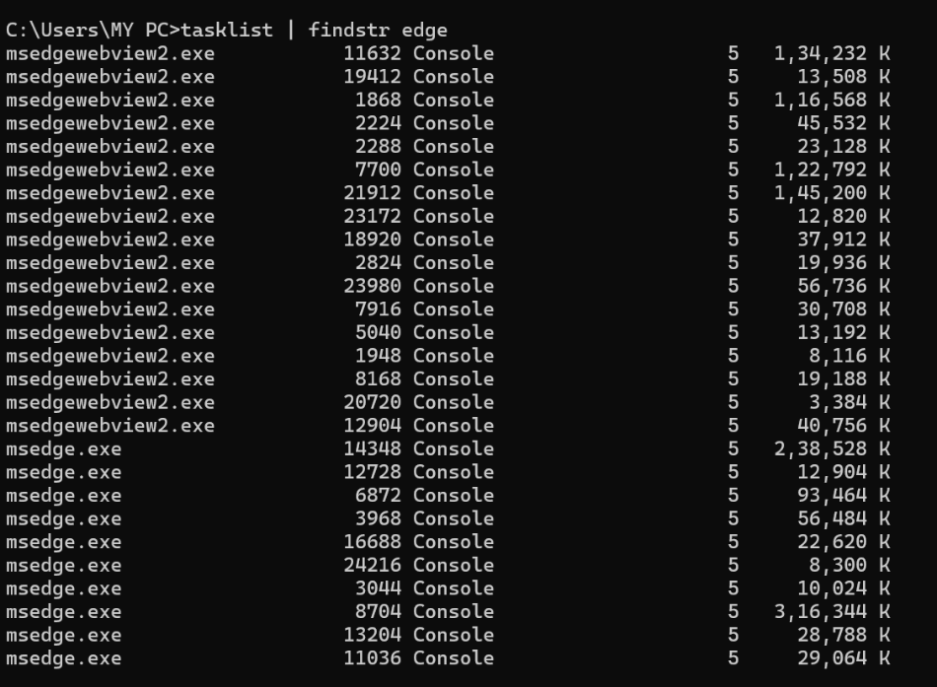
SOC POV
Investigate suspicious processes.

7. Process kill karo
taskkill /PID 1234 /F (To stop the process)
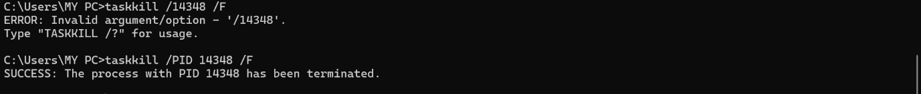
SOC POV
Malware process terminate.

8. Running services check karo
sc query
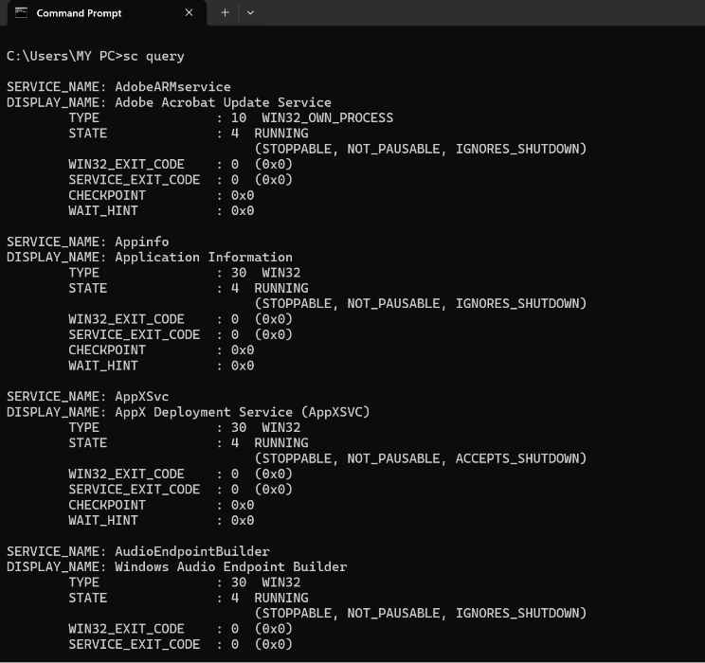
SOC POV
Malware services identify.

9. System users list karo
net user
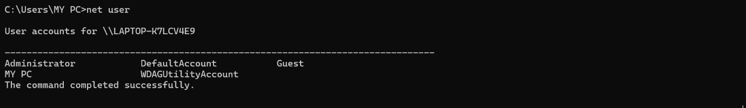
SOC POV
Unknown user account detect.

10. Administrator group members
net localgroup administrators
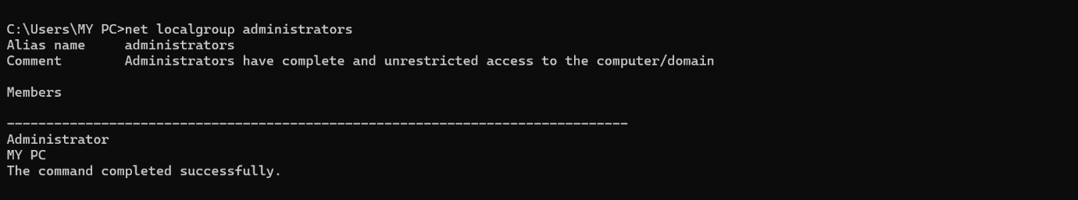
SOC POV
Privilege escalation detect.

